Presenting Atlanta’s

Favorite Restaurants

***Downtown Atlanta ~ Peachtree Street Area***

***Alma Cocina,*** *191 Peachtree Street, N.E*

Cocina introduces Atlanta to a refreshing new approach to modern Mexican cuisine. Bright, fresh ingredients and traditional regional influences come together with other Latin American flavors in a variety of vibrant fresh dishes. We also feature the most unique tequila selections and a host of innovative Latin-influenced cocktails beyond a superior margarita. Lunch & Dinner daily. $$

***Azio’s, in Peachtree Center,*** *229 Peachtree Street, N.E*

This casual, trendy Italian restaurant specializes in creative pizzas. Lunch and dinner daily $

***Barley’s Sports Bar and Lounge*** , *338 Peachtree St*.

Barley’s is a versatile entertainment venue. Patrons dine-in, play billiards, listen to live music, enjoy karaoke, and watch sporting events in a smoke-free environment.

***Big Kahuna***, *303 Peachtree Center Avenue*.

This is Atlanta’s newest destination for lunch, dinner, and late night. Take a break from the mundane and relax at the Big Kahuna, the beach away from the beach. Flat screens, a great bar, and great food await you there.

***Fire of Brazil****, 218 Peachtree Street*

A host of Gauchos parade through the restaurant with choice cuts of grilled Angus beef, chicken, lamb, pork and sausage. All selections are slow roasted over an open flame, seasoned to perfection and accompanied by an extravagant salad area. Fixed priced dining allows you eat until you've had your fill! Lunch and Dinner daily $$

***Hard Rock Café,*** *215 Peachtree St NE*

Situated in downtown Atlanta's Cornerstone Building at the heart of Peachtree Street and Andrew Young International Boulevard, Hard Rock Cafe Atlanta could be considered a cornerstone of southern rock. With its southern charm and renowned hospitality, this location truly gives meaning to our "Love All Serve All" motto. Packed with memorabilia from Hard Rock's world-and serving hearty, fabulous food. Open daily, 11:00AM – 12:00AM $

***Hsu’s****, 192 Peachtree Center Avenue*

The faux-Chinatown exterior of this downtown restaurant gives way to a dimly lit, carpeted interior straight out of "Charlie Chan and the Curse of the Dragon Queen". The menu offers delicious, true flavors of China - Szechwan-style Chinese in a sophisticated setting. Lunch: Mon-Fri; dinner daily $$

***Max Lager’s****, 320 Peachtree Street*

The interior décor resembles an artist’s loft with its brick walls, exposed light fixtures and colorful furniture. This brewery serves your basic American cuisine. Lunch: Mon-Fri. Dinner nightly $

***Meehan’s Public House*,** *180 Peachtree Street*

Meehan’s Public House is an authentic Irish eatery that offers a full menu of classic Irish Dishes elevated to the gourmet level. Meehan’s comfortable yet lively atmosphere is a draw for brunch, lunch, happy hour, dinner, and late night fun. Lunch & Dinner Mon-Friday 11:30am-2:00am; Saturday – 11:00am to 3:00am, Sunday 11:00am-12:00am $

***Morton’s of Chicago*,** *303 Peachtree Center Avenue*

Cozy, modest, minimalist decor makes you feel comfortable upon entering Atlanta’s favorite steak house. Dinner nightly $$$

***Pacific Rim Bistro****, 303 Peachtree Center Avenue, NE*

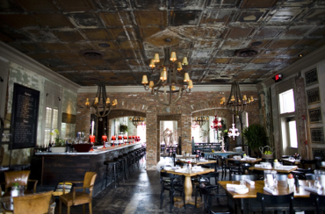Located on the ground floor of Peachtree Center, this attractive, modern bistro features floor-to-ceiling windows, lacquered wicker chairs and a large, horseshoe-shaped sushi bar. Superior sushi and a selection of fusion dishes are the highlights of the pan-Asian menu. Lunch: Mon-Fri. Dinner: Nightly $$

***Ri Ra Irish Pub,*** *1080 Peachtree St*.

Beautifully restored old Irish pub, first class service, lunch & dinner, live entertainment, and banquet facilities is a MUST visit in midtown.

***Rays in the City*,** *240 Peachtree Street*

This place has appetizing dishes to satisfy everyone. Along with their award winning wine list, you will have a very memorable dining experience at Ray's in the City. Lunch and Dinner Daily $$

***Room****, 400 West Peachtree Street*

With a wide selection of small plates and skewered meats and fish with accompanying sauces, broiled and wood grilled meats and fresh fish, sushi and a la carte side dishes Executive Chef Nick Oltarsh highlights dishes with playful, international undercurrents. Room is anything but the typical steakhouse. Open for Lunch and Dinner $$$$

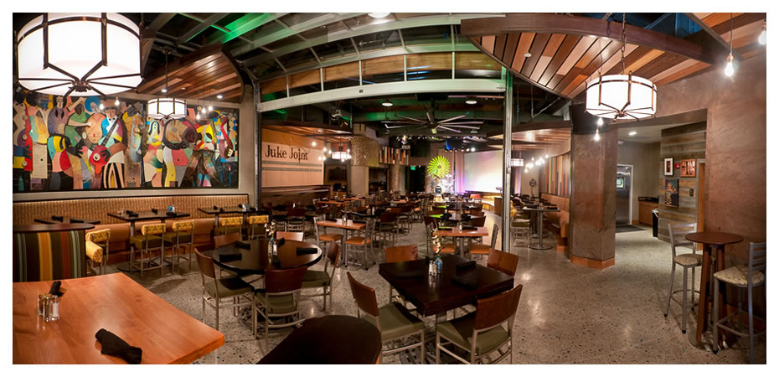***Sweet Georgia’s Juke Joint,*** *200 Peachtree Street*

Sweet Georgia’s Juke Joint is the culmination of a deep history of music, food, and drink, and socializing in the South. Located in the former Macy’s building, in the heart of downtown Atlanta at the iconic 200 Peachtree address, Sweet Georgia’s Juke Joint brings the city to a place to relax while enjoying live entertainment and exceptional cuisine. Lunch and Dinner Daily. $

***White Oak Kitchen & Cocktails****, 270 Peachtree Street*

White Oak Kitchen & Cocktails features chef-inspired cuisine using ingredients fresh from the Southern region. The hospitality and ambiance are locally inspired and crafted, and the cocktails and wines are classic yet fresh. Let their hospitality lift you up! Lunch and Dinner Daily. $$

***[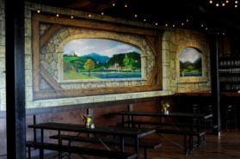](http://www.facebook.com/photo.php?pid=443086&id=146184732075374)Downtown, Luckie Street area***

***Der Biergarten***, *300 Marietta Street Northwest*

An authentic experience is here, giving local residents and visitors a true taste of German culture. Located within the Luckie Marietta District, this happy dining space fills a citywide void for a beer garden and authentic German fare while providing world-class service in a festive, traditional atmosphere. Lunch and dinner daily $

***Legal Seafood,*** *275 Baker Street, NW*

For three generations, Legal Sea Foods has served only the highest quality, freshest fish at a great value. We select the finest and most flavorful goods, demanding nutrition and value as well as great taste from every dish we prepare. And for service, you’ll find no equal. Lunch and dinner: Monday – Saturday. Sunday Brunch $$

***McCormick & Schmicks*,** *190 Marietta Street*

“Steak and seafood are the mainstay but the menu is broad... terrific happy-hour menu... a little more formal than your regular 'tot-friendly' restaurant, but the staff is great and goes out of their way to make sure you're comfortable... try to get one of the banquet rooms -good food for adults and more than enough for the little ones too." Lunch & Dinner Mon-Sat 11am-10pm; Lunch Sun 4pm-9pm $$

### [*Peasant Bistro*](http://rds.yahoo.com/_ylt=A0geu5USn3hJtRwAoFpXNyoA;_ylu=X3oDMTB0a2pha2kyBHNlYwNzYwRjb2xvA2FjMgR2dGlkA0Y4MjRfMTI5/SIG=164uf0cs0/EXP=1232728210/**http%3a/local.yahoo.com/details%3fid=39285572%26stx=peasant%2bbistro%26csz=Atlanta%2bGA%26ed=KpxBgq160Sxj1Z00usCZQZuOgjtKg6GZqi93vvi3MuAsFGJLymkgRipgShkI5a84lOtBVPTMPULpd9NMwo4-), *250 Park Avenue West NW*

Peasant Bistro is a cosmopolitan, dramatic two-story restaurant overlooking Centennial Park and the Atlanta skyline. Featuring fresh, seasonal cuisine, the menu consists of delicious, traditional bistro favorites with French and Mediterranean influence. Lunch and Dinner Daily $

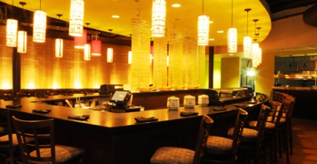***RISE Sushi****, 300 Marietta Street*

Rise Sushi lounge offers a full array of sushi and specialty rolls in a chic modern atmosphere. Conveniently located in the Lucky Marietta District of downtown Atlanta, Rise Sushi can meet all your dining needs Rise is situated just one block from the Georgia Aquarium and Centennial Park and offers complimentary parking for all guests. Lunch and Dinner $$

***Stats*,** *300 Marietta Street*

Are you ready for some "food play?" Simply put, STATS is serious food and serious sports – Premium, food-focused, sports-centered, draught-direct eatery with a high-energy vibe, STATS. Adding to the excitement and anticipation, tap tasters will be mesmerized by the revolutionary beer system incorporated into the restaurant. With 70 high-definition televisions, gourmet American cuisine and beer that literally pours from the tables, the venue will be the definitive spot for sports lovers seeking good meals and libations. Lunch and Dinner $$

***[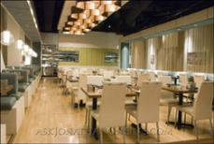](http://www.thriveatl.com/news_image/original/atlantanet.jpg)Thrive****, 101 Marietta Street*

Thrive is an upscale yet casual restaurant located in the heart of downtown. Thrive combines the elements of delicious food and extensive drink choices with a luxury setting. Lunch and Dinner Daily $$

***Downtown Atlanta ~ Old Fourth Ward, Inman Park***

***4th and Swift*,** *621 North Avenue*

Located in the Old Fourth Ward and occupying the space formerly the engine room, it retains many of the original elements. The farm-to-table menu features the freshest of ingredients from all natural and sustainable farmers. The atmosphere contains a sophisticated tavern, kitchen and dining space in which to enjoy the Southern hospitality. Dinner daily $$

***Barcelona Atlanta Wine Bar & Restaurant,*** *240 N. Highland Avenue*

Located just two miles east of downtown Atlanta, Inman Park is not only the home of beautiful Victorian mansions and contemporary lofts, but also a culinary destination. Barcelona offers the neighborhood a delicious array of Spanish small and large plates that turn the mere act of dining out into a joyous communal experience amongst friends and family. $$

***Il Localino****, 467 North Highland Avenue*

Il Localino, a charming family owned & operated Italian Restaurant. Delicious authentic food, fun atmosphere, & fabulous drinks!! The perfect spot for a casual dinner or a major celebration! Whether a romantic table for two, or a private party, Il Localino will exceed all of your dining expectations! Dinner Nightly. $$

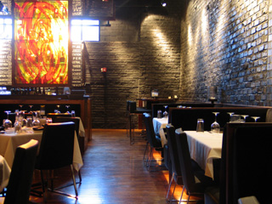

***Kevin Rathbun Steak,*** *154 Krog Street, Ste 200*

From the owners of the nationally acclaimed [*Rathbun's*](http://www.rathbunsrestaurant.com) *&* [*Krog Bar*](http://www.krogbar.com) in Atlanta, Kevin gets his motivation from where he came from .He pays homage to the big league steakhouses. He continues to bring his savvy Kansas City hospitality and his love of entertaining to the Atlanta area. Dinner daily, closed Sunday $$

***Parish***, *240 North Highland Avenue*

Located on the main floor of the historic space, Parish Restaurant serves a variety of New Orleans inspired dishes with modern twists, alongside a classic fully stocked raw bar, seven nights a week. Dinner Daily $$

***Rathbun’s,*** *112 Krog Street*

This Modern-American menu “weaves the richest tapestry of new American cooking”. Located in a 100-year-old building near Inman Park with a modern, warehouse feel, the open kitchen, vibrant colors and jazzy, urban tone excite one immediately after walking through the fuchsia door. Dinner: Mon-Sat $$

***Serpas,*** *#501,659 Auburn Avenue, NE*

The first independent restaurant from revered Atlanta chef Scott Serpas, Serpas is located in reclaimed cotton storage facility at The Pavilion at Studioplex in the historic Old Fourth Ward. The food features cuisine that is true to its origin handcrafted by the New Orleans native chef and owner. Dinner: Tuesday – Sunday. Sunday Brunch $$

***Wisteria***, *471 North Highland Avenue*

Located in the historic Atlanta neighborhood of Inman Park, our cuisine, contemporary American with a Southern twist, is sure to please every palate. Come in and enjoy an inviting and cozy atmosphere with Chef Jason Hill’s seasonal menu.

***Downtown Atlanta ~ Castleberry Hill***

### *No Mas Cantina, 180 Walker Street*

The best of Mexico! It features authentic favorites, outrageous specials, and luscious desserts. It also features handcrafted furnishings and accessories of over 300 artisans in Mexico.

Lunch 11-4: Dinner 4-10 (Fridays and Saturdays till 11): Brunch Saturday and Sunday 11-2.

***Baltimore Crab Seafood,*** *253 Peters Street*

Located in trendy Castleberry Hills, this mostly takeout seafood spot is convenient for Clark Atlanta students.  Order at the counter and  get your seafood fried, broiled, steamed or sauteed.  Home-style sides like mac and cheese, potato salad and corn-on-the-cob give your dinner a comfy finish....that is, unless you also have the very decadent banana pudding.

***255 Tapas Lounge,*** *255 Peters Street*

This is one of Atlanta’s newest hot spots. The music is a mix of old and new, classic and hip-hip. Emphasizing casual dining, social drinking, and a laissez-faire ambiance, 255 is Atlanta’s premier lounge.

***Midtown***

***Baraonda,*** *710 Peachtree Street, NE*

Shadowy hearth light, heavily lacquered plank tables, Italian liqueur posters and plenty of Gypsy Kings tunes make this cozy Midtown trattoria an instant romantic hit. Lunch: Mon-Fri. and Sun. Dinner nightly $

***Davio’s Northern Italian Steakhouse****, 3500 Peachtree Rd.*

Enjoy classic Italian cuisine at Atlanta’s only Northern Italian Steakhouse. Davio’s has a large display kitchen, and in-house bakery, vibrant bar and lounge and outdoor patio.

***Empire State South,*** *999 Peachtree St NE # 140*

Empire State South takes a modern approach to creating authentic Southern dishes, relying on the beautiful foods of this region - a community restaurant that appeals to a broad range, providing a courtyard for bocce ball and an extensive coffee bar. Breakfast, Lunch and Dinner Daily $

***Ecco,*** *40 7th Street, NE*

Located in the heart of Midtown, **Ecco** features seasonally inspired cuisine with Italian, Spanish

and French influences. The atmosphere is welcoming, with a shot of sophisticated, casual

elegance.With its soaring glass entrance and honed marble floors, exhibition kitchen and

wood-burning oven, **Ecco** embraces classic roots while delivering an unmistakably modern and

fresh dining experience. $$

***Escorpion,*** *800 Peachtree Street*

Escorpion is a regionally inspired Mexican tequila bar and cantina capturing the authentic tastes and ingredients indigenous of Mexico.

***Fig Jam Kitchen & Bar***, *3630 Peachtree Road NE*

Fig Jam Kitchen & Bar’s vision is to be seen as a place where customers can create their own custom dining experiences. One of the ways they are doing that is by providing a warm environment where guests can enjoy a good conversation over a variety of dishes and hand crafted drinks with their friends, co-workers and family. Lunch and Dinner Daily. Closed Sunday. $$

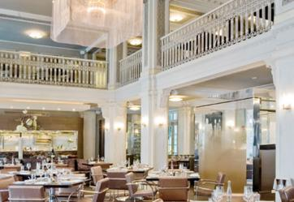***Livingston*,** *659 Peachtree Street*

The new dining destination takes it name frrom. Livingston Mims, who serverd as Atlanta’s mayor during the early 20th.century. The restaurant is located across the street from The Fox Theatre and offers Atlantans an innotive reflection of flavor and history. Breakfast, Lunch and Dinner Daily $$

***Lure****, 1106 Cresent Avenue*

Inspired by classic American and global coastal traditions, Lure presents Atlanta’a freshest fish in the heart of midtown on Cresent Avenue.

***Marlow’s Tavern (Plaza Midtown)*** *950 W. Peachtree St*.

This tavern features American tavern fare served in a modern atmosphere offering classic dished updated and elevated to gourmet level.

***Nan,*** *1350 Spring Street*

Nan creates a glamorous atmosphere for upscale, mild-mannered exquisite Thai food. The restaurant and the food are as sumptuous as any high-end restaurant in Bangkok – without the jet lag. Upscale but not stuffy, spectacular yet quietly restrained, the interior is mesmerizing with a menu to match. Lunch: Mon-Fri. Dinner daily $$

***Oceanaire Seafood Room****, 1100 Peachtree Street, NW*

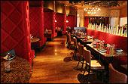With its red leather horseshoe-shaped booths, brass tacks and warm cherry hardwood floors, this lavish seafood restaurant trumpets a global selection of fresh fish and oysters. Lunch Mon-Fri. Dinner daily $$

***One Midtown Kitchen***, *559 Dutch Valley Road, NE*

An 80-foot curved counter bar, towering wine display and vast windows offering lovely views of the midtown skyline are a few reasons you should experience One Midtown. The seasonal menu focuses on small portions, encouraging the diners to share the modern-American cuisine. Dinner daily $$

***Olmsted***, *1180 Peachtree Street, NW*

The name Olmsted pays homage to Frederick Law Olmsted, who is known as the “father of landscape design.” His designs and work greatly influenced the layout of Atlanta and its neighborhoods, but inspiration is not a one-way street. The restaurant Olmsted plays to the memory of Olmsted and his shaping of modern day Atlanta life with Incredible food, and an amazing atmosphere. Brunch and Lunch Daily. $$

***Shout,*** *1197 Peachtree Road, NE*

This ultra hip, luxurious space houses a sushi lounge, intimate dining areas and several bars. Midtowners sip fruity cocktails while hipsters jockey for the best viewing tables, where they eye an eclectic menu of tapas, pizza and sushi. The rooftop lounge with a view of the city is one of the many draws to this great spot! Lunch: Mon-Fri. Dinner daily $$

***South City Kitchen,*** *1144 Crescent Avenue, NE*

This energetic, popular spot offers modern gourmet creations with a southern flair. It’s set in a renovated house accented with an interesting mix of new and old furnishings. Dinner nightly. Sunday brunch $

***The Spence***, *75 5th Street NW*

The Spence is poised to become one of Atlanta's, and the country's top restaurants. Helmed by Chef Richard Blais, recent "Top Chef All-Stars" winner, The Spence, serves classic American dishes as reinterpreted by Blais. Utilizing local ingredients on an ever-changing "pantry list", Blais displays his culinary strengths throughout. The Spence showcases the best in accessible atmosphere, food and beverage. Dinner and Lunch Daily. $$

***Tap***, *1180 Peachtree Street*

A simple and eclectic menu featuring bar snacks, items for sharing and entrees is prepared daily to the highest standards by Chef Todd Ginsberg. His impressive culinary background adds a touch of finesse to TAP’s casual bill of fare. Brunch: Saturday and Sundays $. Lunch: Monday through Friday $. Dinner: Daily $

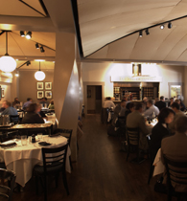

***Veni Vidi Vici***, *41 14th Street, NW*

Situated in an unlikely location on the street level of a parking garage, this authentic home-style Italian restaurant brims with corporate executives, convention crowds, as well as midtown theater goers. Lunch: Mon-Fri. Dinner nightly. $$

***Westside***

***Abattoir*,** *1170 Howell Mill Road*

Abattoir is an American chophouse specializing in the use of locally-raised proteins to produce high-quality, affordable food. Offering freshly butchered whole fowl, fish, beef, pork and other game served in a variety of ways, the menu is based around “whole animal cuisine,” a term referring to the use of every functional piece of the animal. Abattoir was named 2009 Restaurant of the Year by Atlanta Magazine. $$

***Antico Pizza Napoletana*,** *1093 Hemphill Avenue*

Antico Pizza is an authentic Tuscan-style restaurant located in the heart of the Buckhead entertainment district of Atlanta. Marco Bettie invites you to taste the simple, flavorful dishes that have made Italian and Tuscan cooking the most appreciated cuisine in the world combining fresh ingredients with traditional recipes for a dining experience that until now, was only available at his restaurant in San CasCasiano,Italy. $$

***Bacchanalia***, *1198 Howell Mill Road*

Consistently voted number one for food, Bacchanalia, with its cutting edge décor, continues to be ahead of the pack. This chef-owned restaurant makes excellence look effortless. Set in a slick industrial space in an off-beat neighborhood, Bacchanalia has not skipped a culinary beat in achieving transition. Dominique Coyne's reconfiguring of this former meat packing plant built in the 1920s emphasizes clean spaces and retains the old engineering components. Gentle white draping creates a semi-private space for smaller parties. $$$$

***Bocado,*** *887 Howell Mill Road, #2*

The design is a literal translation of the passion for sustainable foods. Keeping with our

commitment to simplicity, Bocado’s design reflects the love of all things natural. The restaurant

utilizes organic, reused materials recreated in inventive and distinctive ways. $$

***Five Seasons Brewery,*** 1000 Marietta Street, NW, # 204

Most of our produce comes from small, local, organic farms. Our chefs actually create 20-30

new specials every day with what comes in fresh from the farms (the "5th Season" is when things

are ripe and in their peak condition!) We brew about 100 different beers every year - our beer list

changes on a continual basis. Our kitchen makes almost everything from scratch. $

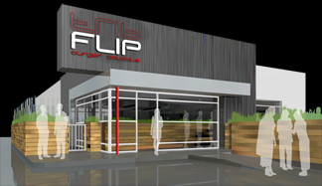***FLIP*,** *1587 Howell Mill Road, NW*

The menu of Flips features thoughtfully paired unique and homemade condiments and sides that complement the burgers. The full drink menu showcases a top selection of beer, wine, martini’s and margaritas. There is a delicious selection of milkshakes at the unique milkshake bar. $$

***JCT Kitchen***, *1198 Howell Mill Road*

JCT. Kitchen opened in January 2007 in the Westside Urban Market of Atlanta’s increasingly trendy West Midtown, JCT. Kitchen & Bar offers upscale, yet casual dining in an atmosphere inspired by the California wine “country” with an East Coast interpretation. This unique neighborhood restaurant features a menu reminiscent of traditional family favorites. Lunch and Dinner (closed on Sundays) $$

***[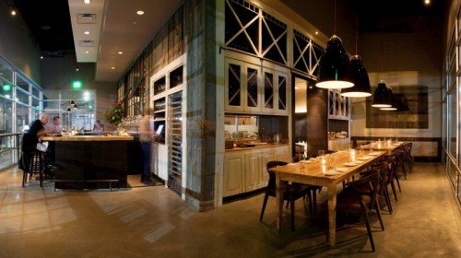](http://www.millerunion.com/site/wp-content/uploads/2009/11/pan_interior2.jpg)Miller Union*,** 999 Brady Avenue

At Miller union, there is a partnership between chef and farmer. The menu is based around the week’s harvest; we take care to preserve the true flavors of our ingredients with a simple rustic preparation. Miller Union’s unique dining space sits on the site once occupied by the Miller Union Stockyards and contributes to the revitalization of Atlanta’s dynamic Westide. $$

***The Optimist*,** 914 Howell Mill Road

The Optimist and Oyster Bar is simply "The Hamptons meets The South". They are passionate about sourcing sustainable seafood and preparing it in classic ways. Menu items range from the most authentic seafood gumbo with "pot luck" garlic bread to Maine lobster rolls, Gulf grouper with smoky spring Vidalias, and an ever changing selection of super fresh East and West coast oysters. Oh... and if you are not a seafood person, they LOVE meat as well! No worries, be optimistic! Lunch and Dinner Weekdays. Dinner Only on Weekends. $$$

***Paschal’s****, 108-B Northside Drive*

Paschal’s is the “soul” of Atlanta, serving favorites like Paschal’s Fried Chicken, Fried Green Tomatoes, and our famous Peach Cobbler. Pashcal’s Restaurant is where southern hospitality lives.

***Taqueria del Sol,*** *1200-B Howell Mill Road*

Taqueria del Sol, is truly one of a kind, juxtaposing the quality of fine dining ingredients against fast-casual prices, and offering authentic Southwestern selections as well as a variety of Southern-inspired menu choices. Christiane Lauterbach of Atlanya Magazine writes, ”to this day, here is no better bang for the buck in Atlanta.” In 2007, BonApetit picked the Atlanta-based chain as a “Top American restaurant.” $

***Virginia – Highlands***

***Dish***, *870 North Highland Avenue, NE*

This urban, eclectic spot draws a trendy crowd for its flavors and combinations. Good looks and New American menu meet at this eye-catching cottage bistro. Dinner nightly $$

***Fritti*,** *311 North Highland Avenue*

Both hip and comfortable, Fritti provides a most authentic Italian dining experience. Newly certified by the Verac Pizza Napoletana Association in Naples, Italy; Fritti features 26 varieties of Neapolitan pizzas prepared in hand-crafted wood-burning ovens. Fritti also offers a variety of Tuscan style wood roasted meats, great fried appetizers and refreshing salads $$

***Harry & Sons***, *820 North Highland Avenue, NE*

The simple flavors are nicely spicy with plenty of non-intimidating meats and heaps of veggies. Make this low-key Thai/sushi bar a must see. Lunch and dinner daily $$

***La Tavola****,* *992 Virginia Avenue, NE*

This modern trattoria dishes up Italian favorites for chic Virginia-Highlanders. With its open kitchen, mirrored walls and delicious Italian cuisine, La Tavola fits right in to its stylish Virginia-Highlands environment. Lunch and dinner nightly. Brunch Sunday. $$

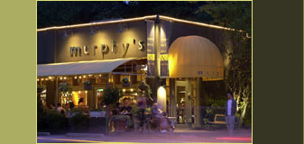***Murphy’s***, *997 Virginia Avenue, NE*

Located in the heart of Virginia Highlands, Murphy’s offers contemporary American comfort food in an upbeat atmosphere. A wine shop and not-to-be missed bakery can also be found in the front of the restaurant. Lunch: Mon-Fri. Dinner nightly, Brunch Sat., Sun. and holidays $

***Noche*,** *1000 Virginia Avenue, NE*

Brilliantly, breathlessly exudes ‘southwestern’. Margaritas and fun will be found under the covered balcony at this friendly spot. Lunch: Sat. and Sun. Dinner nightly. $

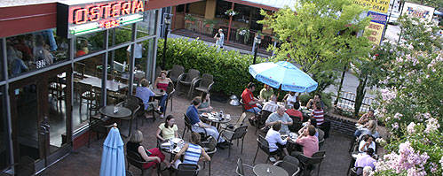***Osteria*,** *832 North Highland Avenue, NE*

A smart and thoroughly unpretentious spot for Neapolitan-style pasta and thin crust pizzas that have become a big hit with Virginia Highlanders. Toppings range from gourmet- minded prosciutto and arugula to spicy salami and mushrooms. Lunch: Tues-Sun. Dinner daily. $

***The Optimist,*** *914 Howell Mill Road*

Ford Fry’s The Optimist brings a classic seafood experience to landlocked Atlantans. From Maine

sea scallops and whole-roasted Georgia trout to garlicky clams and fresh oysters flown in from the East

and West coasts, executive chef Adam Evans serves high-quality and sustainable seafood from

the country’s best suppliers. An extensive selection of beer, wine, and handcrafted cocktails pair

with hickory-roasted fish and raw oysters alike. $$

***The Original El Taco,*** *1186 North Highland Ave.*

Here you’ll enjoy the simple, fresh Mexican food while sipping on our famous margaritas and frozen mojitos.

***Sotto Sotto,*** *313 North Highland Avenue, NE*

Subdued style and authentic Italian ingredients make this a great neighborhood spot and cross-town destination. Dinner: Mon-Sat. $$

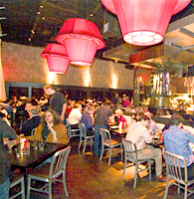

***Two Urban Licks*** (right)*, 820 Ralph McGill Boulevard*

From the creators of One Midtown Kitchen comes a Bar-B-Q joint Bubba never dreamt of. Scallops and duck along with traditional favorites on the menu taste as good as they sound. Fantastic, lively interior encased by a stunning view of the city. $$

***Vine*,** *1190 North Highland Avenue*

Offering a world-class eclectic menu updated monthly, Vine is a perfect example of what makes Virginia Highlands so unique. Whether seated on the outside patio or next to the double sided fireplace, you’ll enjoy comfort, character and an award-winning wine list. Dinner nightly. Lunch: Reservations only. Brunch Sunday $

***Atlantic Station***

***Lobby at Twelve*,** *361 17th Street NW*

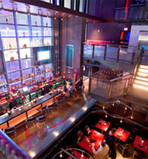Lobby is a high energy casual dining American Kitchen serving great food and drinks. With an open kitchen and great lobby bar with its wood fire pizza oven, Lobby becomes a great gathering place to graze, sip, wine or dine. Lunch and Dinner. $$

***Rosa Mexicano,*** *245 18th Street NW*

The restaurant delivers the winning combination of authentic Mexican cuisine in an exciting, modern and friendly environment. A dramatic 18' high waterwall is the eye-catching centerpiece of the 200-seat restaurant, which also features a lounge area and a private dining area that will accommodate up to 60 guests. $$

***Strip,*** *245 18th Street*,

Strip offers a menu of Steaks, Sushi and Teasers. Lunch and Dinner Daily $$

***Aja****,* 3500 Lenox Road, Suite 100

A modern Asian Kitchen, this two story environment consists of a private dining room which seats up to 30 guests, a 150 seat patio with views of the Buckhead skyline and sprawling lounge area where guests can enjoy dim sum, signature mai tai's and more! The restaurant is the home to a 10 ft brass Buddha that arrived straight from Thailand. Private dining available. Lunch: Mon-Sat. Dinner nightly. $$

***Anis****, 2974 Grandview Avenue, NE*

This Buckhead French Bistro offers a wonderful meal at a very reasonable price. Its cozy setting in a charming bungalow attracts quite a following of devotees to this romantic spot. Private dining available. Lunch: Mon-Sat. Dinner nightly. $$

***Antica Posta****, 519 East Paces Ferry Road, NE*

This cozy bungalow with wooden beams warms the dining room of white-clothed tables. This little Italian main-stay bestows Atlantans with a taste of the Tuscan good life. Dinner nightly. $$

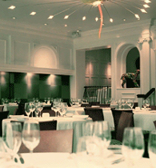

***Aria****, 490 East Paces Ferry Road, NE*

This new American savory menu includes fork-tender braised short ribs and Gorgonzola polenta, while seasonal offerings include enormous soft-shell crabs spiked with dill and delicate fish with direct-from-the-garden vegetables. The seductive surroundings include architecture from yesteryear and post modern art. Dinner: Mon-Sat. $$$

***The Atlanta Fish Market***, *265 Pharr Road, NE*

You are greeted by a most impressive outdoor bronze fish sculpture as you arrive at this upscale Buckhead fish house. An aromatic fish market display contains an extensive array of fresh seafood. Lunch: Mon-Sat. Dinner nightly. $$$

[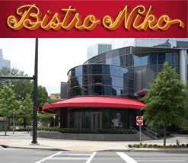](http://atlantafinehomes.files.wordpress.com/2009/08/image001.jpg)

**Bistro Niko**, *3344 Peachtree Road*

Located in the spectacular [Sovereign](http://sovereignbuckhead.com) Building, Bistro Niko is an exciting French bistro, with cuisine that offers a lighter style of classic French cooking, as is the trend in Paris today. Lunch and dinner served seven days a week, a special brunch menu available on Sunday. $$

***Blue Ridge Grill****, 1261 West Paces Ferry Road*

The mountains meet the city in this rustic Buckhead home to winning American cuisine. Classic Southern and American dishes get the upscale treatment with largely winning results. Lunch: Sun-Fri. Dinner nightly. Sunday brunch. $$$

***Bone’s,*** *3130 Piedmont Road, N.E.*

Thickest and juiciest steaks in town. Atlantans have been gathering here since 1979 for the best prime rib, steaks, lamb chops, and live Maine lobsters (flown in daily). $$$

***BrickTop’s*,** *3280 Peachtree Street*

BrickTop's is a Nashville based company. It is the company's goal to balance high standards and quality with an unassuming atmosphere. BrickTop's is a place where it's pleasant to dine or have a drink after work. The restaurant is sophisticated, warm and friendly. From the greeters and service staff to the kitchen and management, everyone takes pride in their job. Lunch and Dinner daily $$

***Buckhead Bottle Bar and Bistro***, 268 East Paces Ferry Road

Buckhead Bottle Bar, a trendy and stylish restaurant, serves unique bites and well-crafted cocktails.$$

***The Buckhead Diner,*** *3073 Piedmont Road, NE*

This gleaming monument to American culinary chic of the late 1950’s offers hearty American cuisine. “Comfort food gone gourmet” is the by-word at this well-known establishment. Lunch and dinner daily. Sunday brunch. $$

***Capital Grille***, *255 East Paces Ferry Road*

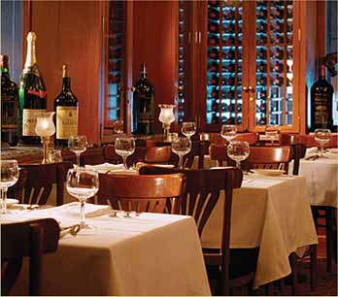Boasting an atmosphere of energy, sophistication and power dining, The Capital Grille serves classic steak house offerings and raises the all around experience to a level of excellence. Best View in town! Lunch Mon – Fri. Dinner Nightly. $$$

***Canoe*,** *4199 Paces Ferry Road, NW*

Situated on the banks of the Chattahoochee River, this is a favorite for “special occasion” destinations. It’s a pure visual delight with its lovely patio and gorgeous gardens. Lunch: Mon-Fri. Dinner nightly. Sunday Brunch. $$

***Cantina,*** *3280 Peachtree Street*

Here to Serve welcomes their first Mexican concept, Cantina, located at the Terminus building at the corner of Peachtree and Piedmont in Buckhead. The interior houses a modern design by Johnson Studios. Two outdoor patios: one for dining and one lounging and enjoying signature margaritas. Lunch and Dinner $$

***Chops & Lobster Bar***, *70 West Paces Ferry Road, NW*

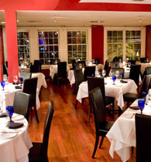Atlanta’s “Tiffany of steakhouses” featuring seafood, as well as beef, it offers excellent service in a comfortable, clubby setting. The downstairs Lobster Bar (dinner only) is a seafood lover’s paradise. Lunch: Mon-Fri. Dinner nightly. $$$

***Coast,*** *111 West Paces Ferry Road (right)*

Coast Seafood and Raw Bar serves Atlanta’s freshest seafood and island cocktails! Classics include crab and corn hush puppies, a signature seafood boil, and a variety of raw or steamed oysters, clams and mussels; along with signature fresh catch entrees. Large patio area for dining extended bar area, seating for over 100 and private dining. Dinner nightly - Sunday brunch $$

***Eclipse di Luna***, *764 Miami Circle, NE*

This festive, high-energy, interactive dining experience offers an artsy setting as a backdrop for award- winning specialty tapas and live music nightly. Belly up to the bar and enjoy authentic Spanish cuisine. Lunch: Tues-Sat. Dinner: Tues-Sun. $

***F&B Atlanta***, *3630 Peachtree Road NE*

A “local Neighborhood Bistro”, located in the heart of Buckhead serving Americanfood with French twist. F&B is great for a casual drink, or a delicious meal. The atmosphere will captivate you. Lunch and Dinner Daily. $$

***Fogo de Chao***, *3101 Piedmont Road, NE*

This Brazilian churrascaria-style steakhouse is a meat lovers delight featuring fifteen types of perfectly roasted meat that is carved from skewers at your table by knife wielding gauchos. Lunch: Mon-Fri. Dinner nightly. $$$

***Hal’s,*** 30 *Old Ivy Road*

A restaurant that triumphs in taste over trend, Hal's is not the typical highbrow restaurant so often equated with food of this quality. It is a place of white table cloths, flowers, warm brick, & candlelight. Dinner Nightly. Closed on Sunday. $$$

***Horseradish Grill***, *4320 Powers Ferry Road, NW*

A neighborhood “barn” and grill next to Chastain Park is a one of a kind eating establishment that makes you feel “at home”. A creative menu that offers a most unique style of Southeastern cooking from North Carolina to the Georgia mountains Lunch: Mon-Fri. Dinner nightly. Brunch Sunday. $$

***Kyma***, *3085 Piedmont Road, NE*

Kyma offers magnificent authentic Greek cuisine in an uptown setting. This unique Buckhead restaurant is sure to be a “favorite spot”’ to many! Dinner: Mon-Sat. $$$

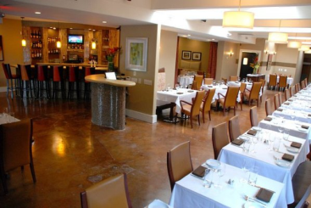

***La Fourchette,*** *3133 Piedmont Road Northeast*

A true Mediterranean delight - *la Fourchette* - picks up on warm notes from France, Italy, and Spain to create a cuisine unique to itself. French trained Chef Jeffrey Wall, a former member of the JOEL Brasserie team, brings a young and refreshing twist on traditional dishes allowing the food to speak for itself! $$

***La Grotta***, *2637 Peachtree Road, NE*

Ranked among Atlanta’s finest restaurants old world charm and sophisticated cuisine come together to make for an elegant affair - Northern Italian dishes prepared with veal, seafood or pasta are uniformly excellent. Dinner: Mon-Sat. $$$

***Local Three***, *3290 Northside Parkway, Suite 120*

Using one the best kitchens in the country, Local Three presents a neighborhood spot with really good food, beverage and service! Join them for a come-as-you-are atmosphere and "foie gras in your flip flops" ambiance with the best quality cuisine at affordable prices alongside intriguing wine and beer lists and a full bar. Lunch and Dinner Weekdays. Brunch Sunday, Dinner on Weekends. $$

***Market Buckhead***, *W Hotel Buckhead, 3377 Peachtree Rd*.

The concept of the hotel-as-a-home extends to these restaurants as its casual family kitchen by Jean-Georges.$

***Ocean Prime,*** *3102 Piedmont Road Northeast*

Seafood or Steak? At Ocean Prime you can choose the best of both. Add in world class wines, award-winning handcrafted cocktails, timeless elegance and take-your-breath-away service. Their passion is to give you an extraordinary supper club experience. Dinner Nightly. $$$

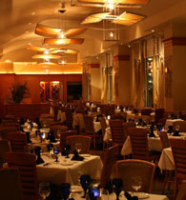***Paul’s***, *10 King Circle*

You’ll find luxurious American food with a continental flair and a full sushi bar in this Peachtree Hills neighborhood spot. A piano accompanies meals Wednesday through Saturday, and at Sunday brunch. Lunch and dinner Weds-Sat - Brunch Sunday $

***Portofino***, *3199 Paces Ferry Place*

Enjoy simpler dishes of rustic, regional Italian cooking at a restaurant whose prices are more than fair for the quality of food. The dining room and adjacent bar are awash with a warm glow that make you feel right at home. Lunch: Mon-Fri. Dinner nightly $$

***Pricci,*** *500 Pharr Road*

Wood burning ovens grace the center of this establishment making it one of the most unique places in town. Here you can relish in authentic Italian cuisine while dining in this elegant, modern atmosphere. Lunch: Mon-Fri. Dinner nightly $$$

***Prime,*** *3393 Peachtree Road, NE*

Steaks are supreme--and seafood and sushi fare well--at this attractive Buckhead hot spot. Blonde wood, marble floors, gauzy drape and flattering lighting invites a casually chic crowd. Prime’s lively bar and posh dining room are located in the prestigious Lenox mall. Lunch: Mon-Sat. Dinner nightly $$$

***Restaurant Eugene***, *2277 Peachtree Road*

Award-winning Restaurant Eugene is a quiet, sophisticated fine dining restaurant located in South Buckhead on Peachtree Road. The cuisine is Seasonal New American, with a special emphasis placed on using fresh ingredients from local farmers and specialty purveyors from around the world. Recipient of the 2005 and 2006 Wine Specialist Award of Excellence! Lunch and Dinner $$

***STG Trattoria,*** *102 West Paces Ferry*

STG presents local and seasonal culinary offerings hedged in Italian institution. Most prominently, the "Trattoria" will features an APN-approved, traditionally regulated Neapolitan pizza crafted "from scratch" and baked in 5,000 pound, wood-fired Acunto ovens shipped from Naples, Italy and a walk in wine cellar. The emphasis of STG is on traditional execution, ingredient quality, and a slightly disciplined creativity. Brunch and Dinner Daily. Closed on Mondays for Dinner. $$

***Watershed***, *1820 Peachtree Road Northwest*

Owner Emily Sailers (of the Grammy Award winning *Indigo Girls*), made the decision to join forces with Chef Scott Peacock and reopen Watershed in the heart of Buckhead. This Peachtree location continues the restaurant’s long standing commitment to its founding principles with great attention to detail and community consciousness. The environment and farm to table approach will be sure to appease your pallet and create for a wonderful experience. Lunch and Dinner Daily. Open Sunday for brunch. Closed on Mondays. $$

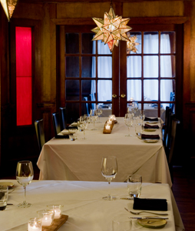

***Woodfire Grill*,** *1782 Cheshire Bridge Road*

Executive Chef (and *Top Chef*) Kevin Gillespie incorporates the seasonal offerings of small local farms and purveyors as well as sustainable beef, lamb, pork, poultry and seafood for simply prepared cuisine. Foods are fire-roasted and grilled with a menu comprised of first, second and main courses in addition to chef's tasting menus. Dinner $$

*$25.00 and less $*

*$50.00 and less $$ $75.00 and less $$$*

*More than $75.00 $$$$*